**MUSIC LIBRARY DATABASE**

#To create database

CREATE DATABASE MUSIC_LIBERARY;

#To select database

USE Music_Liberary;

#To create table in database

CREATE TABLE Music

(

M_Id int PRIMARY KEY,

M_Name VARCHAR(20) not null,

Singer VARCHAR(20) not null,

R_Date date not null

);

#To describe structure of table

DESC Music;

#To retrieve data from table

SELECT * FROM Music;

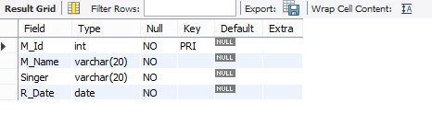

#To add data in table

INSERT Music VALUES(1,'Sanam re','Arijit Singh','2020-02-10'),

(2,'Khamoshiya','Sonu nigam','2021-05-20'),

(3,'Desi boys','Mika Singh','2018-03-30'),

(4,'Tum hi ho','Arijit Singh','2022-08-15'),

(5,'Uad ja kale kawa','Udit Narayan','2010-12-28');

SELECT * FROM Music;

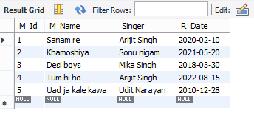

#To add new column to the table

ALTER TABLE Music

ADD COLUMN Movie_name VARCHAR(20) not null;

SELECT * FROM Music;

#To turn off safe mode

SET SQL_SAFE_UPDATES=0;

#To update values for new column

UPDATE Music

SET Movie_name ='Sanam re'

WHERE M_Id=1;

UPDATE Music

SET Movie_name ='Sholey'

WHERE M_Id=2;

UPDATE Music

SET Movie_name ='Agnipath'

WHERE M_Id=3;

UPDATE Music

SET Movie_name ='Gadar'

WHERE M_Id=4;

UPDATE Music

SET Movie_name ='Hera Pheri'

WHERE M_Id=5;

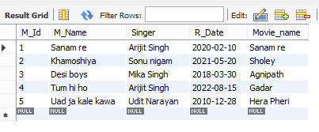

SELECT * FROM Music;

ALTER TABLE Music

ADD COLUMN Singer_payment int not null;

SET SQL_SAFE_UPDATES=0;

UPDATE Music

SET Singer_payment =100000

WHERE M_Id=1;

UPDATE Music

SET Singer_payment =120000

WHERE M_Id=2;

UPDATE Music

SET Singer_payment =590000

WHERE M_Id=3;

UPDATE Music

SET Singer_payment =300000

WHERE M_Id=4;

UPDATE Music

SET Singer_payment =99000

WHERE M_Id=5;

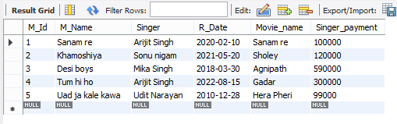

SELECT * FROM Music;

#Arithmetic operators

#ADDITION

SELECT M_Name, Singer_Payment+100000 AS 'New Payment' from Music;

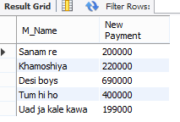

#SUBTRACTION

SELECT M_Name, Singer_Payment-10000 AS 'Deduction of Payment' from Music;

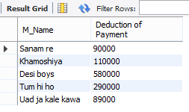

#RELATIONAL OPERATORS

#GREATER THAN OR EQUAL TO

SELECT * FROM music

where Singer_Payment>=100000;

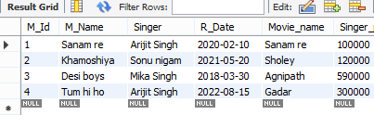

#LESSER THAN OR EQUAL TO

SELECT * FROM music

where Singer_Payment<=200000;

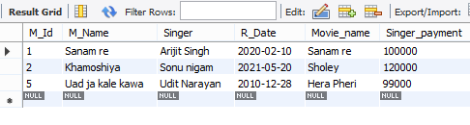

#BETWEEN AND

SELECT * FROM music

where Singer_Payment BETWEEN 100000 AND 300000;

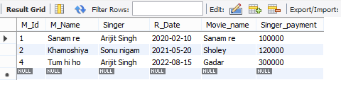

SELECT * FROM Music

WHERE Singer in('Arijit Singh', 'Mika Singh', 'Udit Narayan');

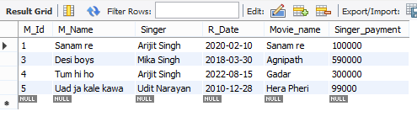

#LIKE OPERATORS

SELECT * FROM Music

WHERE M_Name LIKE '%A';

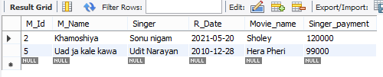

SELECT * FROM Music

WHERE M_Name LIKE '___A%';

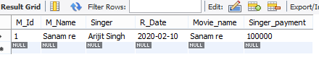

#LOGICAL OPERATORS

#AND

SELECT * FROM Music

WHERE Singer='Arijit Singh' And M_name='Sanam Re';

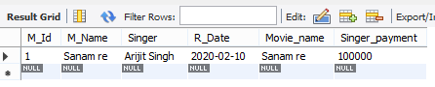

#OR

SELECT * FROM Music

WHERE Singer='Arijit Singh' OR M_name='Desi boys';

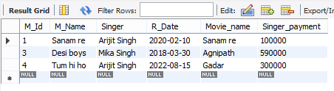

#NOT

SELECT * FROM Music

WHERE NOT Singer='Arijit Singh';

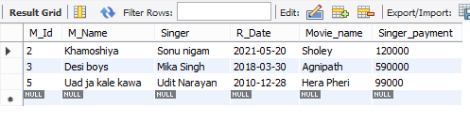

#AGGREGATE FUNCTIONS

SELECT COUNT(M_Id) AS 'Total ID' FROM Music ;



SELECT MIN(Singer_Payment) FROM Music ;

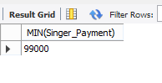

SELECT MAX(Singer_Payment) FROM Music;

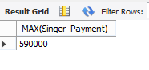

SELECT SUM(Singer_Payment) FROM Music ;

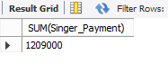

SELECT AVG(Singer_Payment) FROM Music;

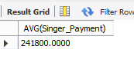

#SINGLE ROW FUNCTION

SELECT UPPER(Singer) FROM Music;

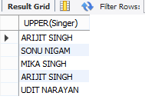

SELECT LOWER(Singer) FROM Music;

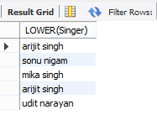

SELECT CONCAT(Singer,Singer_Payment) FROM Music;

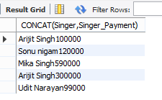

SELECT Singer, REPLACE('Arijit Singh','A','T') AS 'Replaced Name' FROM Music

WHERE M_Id=1;

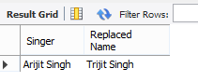

SELECT Singer, SUBSTR('Mika Singh',1,3) FROM Music

WHERE M_Id=3;



SELECT Singer, SUBSTR('Sonu Nigam',6,8) FROM Music

WHERE M_Id=2;

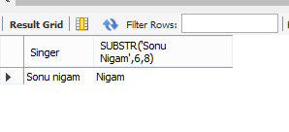

SELECT sqrt(Singer_Payment) from Music;

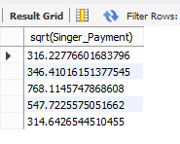

SELECT ROUND(Singer_Payment) from Music;

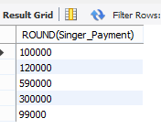

SELECT MOD(10,422);

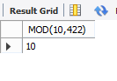

SELECT current_timestamp();

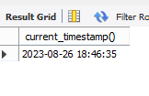

SELECT current_time();

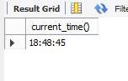

select current_date();

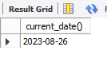

SELECT current_user();

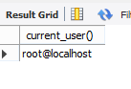

#GROUP BY CLAUASE

SELECT Singer, MAX(Singer_Payment)

FROM Music

GROUP BY M_Id

Having MAX(Singer_Payment)>=100000;

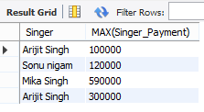

#SUB QUERY

select * from Music

WHERE Singer_Payment=

(

select max(Singer_Payment) from Music

);

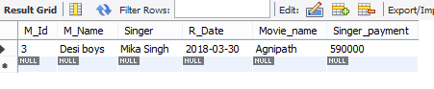

select * from Music

WHERE Singer_Payment=

(

select MIN(Singer_Payment) from Music

);

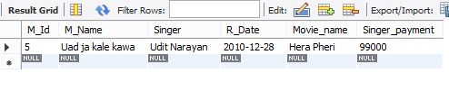

select * from Music

ORDER BY Singer_Payment desc

limit 1

offset 2;

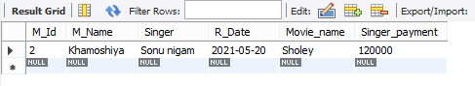

#To create table

CREATE TABLE Music_review

(

S_Id int PRIMARY KEY ,

M_lOCATION VARCHAR(20) NOT NULL,

Views int NOT NULL,

R_platform VARCHAR(20) NOT NULL,

M_Id int,

Foreign key (M_Id) references Music(M_Id)

);

DESC Music_review;

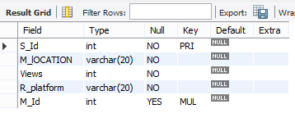

INSERT Music_review VALUES(1,'Shimla',2000000,'Youtube',1),

(2,'Manali',2000000,'Spotify',2),

(3,'Delhi',350000,'wynk',3),

(4,'Mumbai',535423,'jio savan',4),

(5,'Dehradun',124525,'Youtube',5);

SELECT * FROM Music_review;

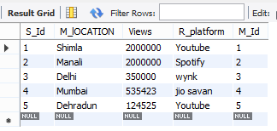

#JOINS

SELECT * FROM Music,Music_review

where Music.M_Id=Music_review.M_Id;

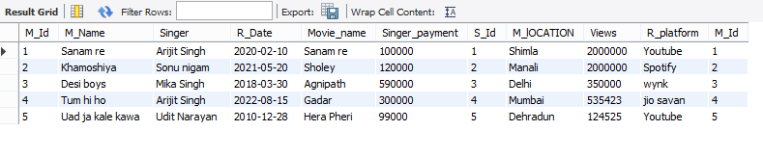

SELECT * FROM Music

JOIN Music_review

ON Music.M_Id=Music_review.M_Id;

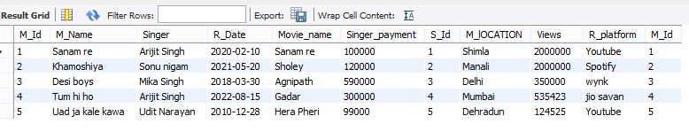

#INNER JOIN

SELECT * FROM music INNER JOIN Music_review

ON Music.M_Id=Music_review.M_Id;

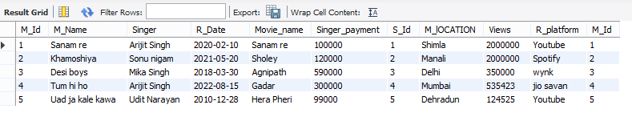

#OUTER JOIN

SELECT * FROM Music LEFT OUTER JOIN Music_review

ON Music.M_Id = Music_review.M_Id;

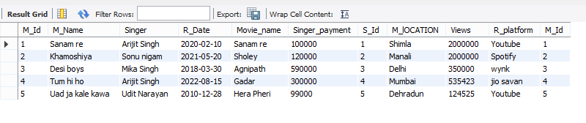

SELECT * FROM Music RIGHT OUTER JOIN Music_review

ON Music.M_Id = Music_review.M_Id;

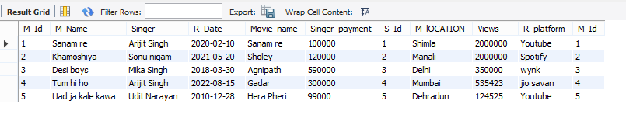

**DONE BY**

Tanmay

Sowjanya bhat

Ajay singh

Devi dayal